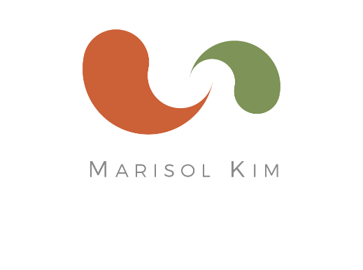
Marisol Kim, CNC
Certified Nutrition Consultant

marisolkim.com
marisolkim1@gmail.com
cell 201-916-0373
3821 23rd St
San Francisco, CA 9411
Rates and Service Details

Package A: Three-Month Health & Nutrition Reset Program
- $1,096 (if paid in full)
- $1,190 (2 installments of $680 and $510)
- $1,294 (3 installments of $680, $307, and $307)

Services include:
- One Complete Assessment and Recommendations Session (3-hours)
- Four Follow-ups (1 hour each session)
- BONUS: Nutrition Education, Email coaching, support and Q&A throughout program
- Program Features listed below.
- Note: Program to be completed within 3.5 months.

Package B: Six-Month Health & Nutrition Comprehensive Program
- $1,796 (if paid in full)
- $1,894 (3 installments $860, $517, and $517)
- $2,014 (5 installments: 1st is $734, and then 4 X $320)

Services include:
- One Complete Assessment and Recommendations Session (3-hours)
- Eight Follow-ups (1 hour each session)
- BONUS: Nutrition Education, Email coaching, support and Q&A throughout program
- Program Features listed below.
- Note: Program to be completed within 7 months.

Program Features Includes:

- Initial Assessment Sessions: During the first session, I check health history, fully assess the root of the health challenges, talk about current health goals, and create a health and nutrition plan customized to fit your lifestyle.

- List of Foods: During the assessment, you will receive an individualized list of recommended foods (those to increase, and those best avoided).

- Follow-up sessions: check in, plan the following action step, assess progress, make adjustments to the program, and to re-test as needed.

- Discussion and education on your individual health condition; assessing the root of your health challenges, and customize a step-by-step action plan that fits your lifestyle.

- Resources: shopping, restaurant recommendations in the Bay Area, products and brands of healthy foods, sources of healthy food delivery in the Bay Area

- You will receive expert nutrition & lifestyle recommendations, coaching, action steps. Together, we will create a plan that supports your unique needs and fits into your lifestyle.

Custom Nutritional Solutions including:
  - Diet evaluation, analysis, and full assessment of individual health needs
  - Custom research and nutrition information with handouts
  - Introduction of foods to support your specific health goals
  - Quick, easy, and healthy whole foods recipes, customized menus and meal plans, and cooking tips
  - Customized supplements and herbs (Additional cost)
  - Recommendations for restaurants, natural food stores, farmer’s markets, books, and more!
  - Email coaching and Q&A throughout program
  - Access to lab testing (Additional cost)

