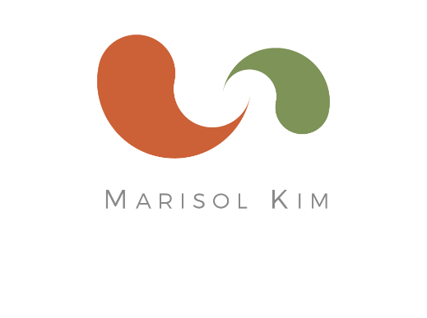
Marisol Kim, CNC
Certified Nutrition Consultant

marisolkim.com
marisolkim1@gmail.com
cell 201-916-0373
3821 23rd St
San Francisco, CA 94114
Rates and Service Details

Package A: Three-Month Health & Nutrition Reset Program
Total of 7 hours of in-person sessions, plus email communication and support throughout the program.

- $1,295 (if paid in full)
- $1,395 (2 installments of $750 and $645)

Service details:
- One Complete Assessment and Recommendations Session (3-hours)
- Four Follow-ups (1 hour each session)
- BONUS: Nutrition Education, Email coaching, support and Q&A throughout program
- Plus Program Features listed below.

Package B: Six-Month Health & Nutrition Comprehensive Program
Total of 11 hours of in-person sessions, plus email communication and support throughout the program.

- $1,995 (if paid in full)
- $2,175 (3 installments $895, $640, and $640)

Services include:
- One Complete Assessment and Recommendations Session (3-hours)
- Eight Follow-ups (1 hour each session)
- BONUS: Nutrition Education, Email coaching, support and Q&A throughout program
- Program Features listed below.

Program Features Includes:

- Initial Assessment Sessions: During the first session, I check health history, fully assess the root of the health challenges, talk about current health goals, and create a health and nutrition plan customized to fit your lifestyle.

- List of Foods: During the assessment, you will receive an individualized list of recommended foods (those to increase, and those best avoided).

- Follow-up sessions: check in, plan the following action step, assess progress, make adjustments to the program, and to re-test as needed.

- Discussion and education on your individual health condition; assessing the root of your health challenges, and customize a step-by-step action plan that fits your lifestyle.

- Resources: shopping, restaurant recommendations in the Bay Area, products and brands of healthy foods, sources of healthy food delivery in the Bay Area

- You will receive expert nutrition & lifestyle recommendations, coaching, action steps. Together, we will create a plan that supports your unique needs and fits into your lifestyle.

Custom Nutritional Solutions including:
  - Diet evaluation, analysis, and full assessment of individual health needs
  - Custom research and nutrition information with handouts
  - Introduction of foods to support your specific health goals
  - Quick, easy, and healthy whole foods recipes, customized menus and meal plans, and cooking tips
  - Customized supplements and herbs (Additional cost)
  - Recommendations for restaurants, natural food stores, farmer’s markets, books, and more!
  - Email coaching and Q&A throughout program
  - Access to lab testing (Additional cost)

