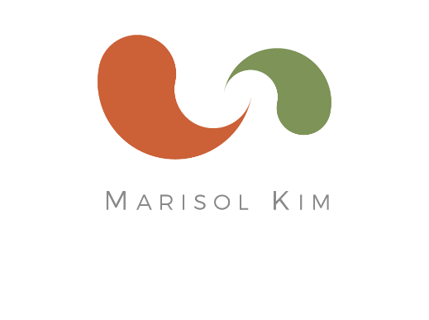
Marisol Kim, CNC
Certified Nutrition Consultant

marisolkim.com
marisolkim1@gmail.com
cell 201-916-0373
3821 23rd St
San Francisco, CA 9411

Rates for Continuing Clients

Single Session
$285 (1 hour) *
Includes 1 week of email communication after session

2.5 Month Program
$750
Package of 3 (1 hour) Sessions *
Includes email communication for 2.5 months

4 Month Program
$1,096
Package of 5 (1 hour) Sessions *
Includes email communication for 4 months

* $45 for each additional 15 minutes

