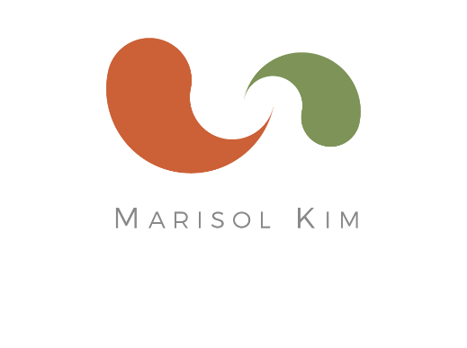
Marisol Kim, CNC
Certified Nutrition Consultant

marisolkim.com
marisolkim1@gmail.com
cell 201-916-0373
3821 23rd St
San Francisco, CA 94114

Rates for Continuing Clients

Single Session
$329
Session is 1 hour
Includes 1 week of email communication after session

Package of 3 Sessions
$885
(Each session = $295)
Total of 3.5 hours of in-person sessions
Plus email communication for 2.5 months

Package of 5 Sessions
$1,295
(Each session = $259)
Total of 5.5 hours of in-person sessions
Plus email communication for 4 months

